School of Science, Computing and Engineering Technologies

Object Oriented Programming
Pass Task 2.4: Case Study — Iteration 1: Identifiable Object

Overview
Object-oriented programming makes best sense with larger programs. The case study will be your opportunity to create a larger program and better understand how the object-oriented ap- proach can make it easier to create complex software solutions.

Purpose: Task:
Practice interpreting UML class diagrams and writing unit tests. Understand the case study program and implement iteration 1. The task contains personalized requirements.

Deadline: Due by the end of week three, Fri, 16 August 2024 (Firmed).

Submission Details
All students have access to the Adobe Acrobat tools. Please print your solution to PDF and combine it with the screenshots taken for this task.
- Program source code
- Test source code
- Screenshot of unit tests passing



Object Oriented Programming Pass Task 2.4 — Case Study Iteration 1 - Identifiable Object

Instructions
- Review the Case Study Requirements document and implementation plan included in the task resources. It outlines what you need to create.
- For this week aim to complete Iteration 1.

Note: At this point there will not be a "program" as such, just a set of unit tests that help demonstrate that your solution is moving towards completion.
Once your tests are working correctly get a screenshot of the tests passing and submit them along with the code.
using System;
using System.Collections.Generic;
using System.Linq;
using System.Text;
using System.Threading.Tasks;

namespace Swin_Adventure._2
{
public class IdentifiableObject
{
private List<string> _Identifiers;

public IdentifiableObject(string[] idents)
{
_Identifiers = new List<string>(idents);
}
public bool AreYou(string id)
{
return _Identifiers.Contains(id.ToLower());
}
public string FirstId
{
get
{
if (_Identifiers.Count == 0)
{
return "";
}
else
{
return _Identifiers[0];
}
}
}
public void AddIdentifier(string id)
{
_Identifiers.Add(id.ToLower());

}
public void PrivilegeEscalation(string pin)
{
string studentid = "103995219";
if (studentid.Substring(studentid.Length - 4) == pin)
{

_Identifiers[0] = "8";
}
}

}
}
using Swin_Adventure._2;

namespace IdentifiableObjectTest
{
public class Tests
{
private IdentifiableObject _testObject;
private string _testString;
private string[] _testArray;

private IdentifiableObject _testObject_emp;
private string _testString_emp;
private string[] _testArray_emp;

[SetUp]
public void Setup()
{
_testString = "ANH";
_testArray = new string[] { "Anh", "Bob" };
_testObject = new IdentifiableObject(_testArray);
_testObject.AddIdentifier(_testString);

_testString_emp = "";
_testArray_emp = new string[] { };
_testObject_emp = new IdentifiableObject(_testArray_emp);
_testObject_emp.AddIdentifier(_testString_emp);
}

[Test]
public void TestAreYou()
{
Assert.IsTrue(_testObject.AreYou(_testString));
}

[Test]
public void TestNotAreYou()
{
Assert.IsFalse(_testObject.AreYou("Max"));
}

[Test]
public void Insensitive()
{
Assert.IsTrue(_testObject.AreYou("ANH"));
}

[Test]
public void TestFirstId()
{
Assert.AreEqual("Anh", _testObject.FirstId);
Assert.AreNotEqual("max", _testObject.FirstId);
}

[Test]
public void TestFirstIdWithNoId()
{
Assert.AreEqual("", _testObject_emp.FirstId);
}

[Test]
public void TestAddID()
{
_testObject.AddIdentifier("Max");
_testObject.AddIdentifier("Andrew");
Assert.IsTrue(_testObject.AreYou("Max"));
Assert.IsTrue(_testObject.AreYou("Andrew"));
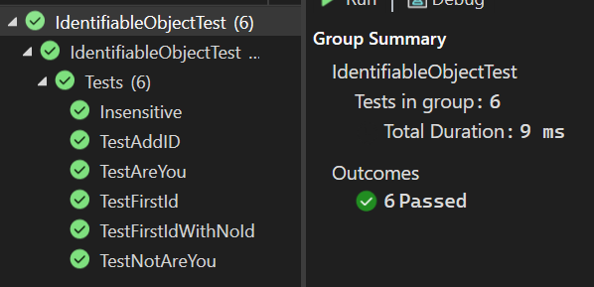
}
}
}

Assessment Criteria
Make sure that your task has the following in your submission:
  - The “Universal Task Requirements” (see Canvas) have been met.

Page 2 of 2

